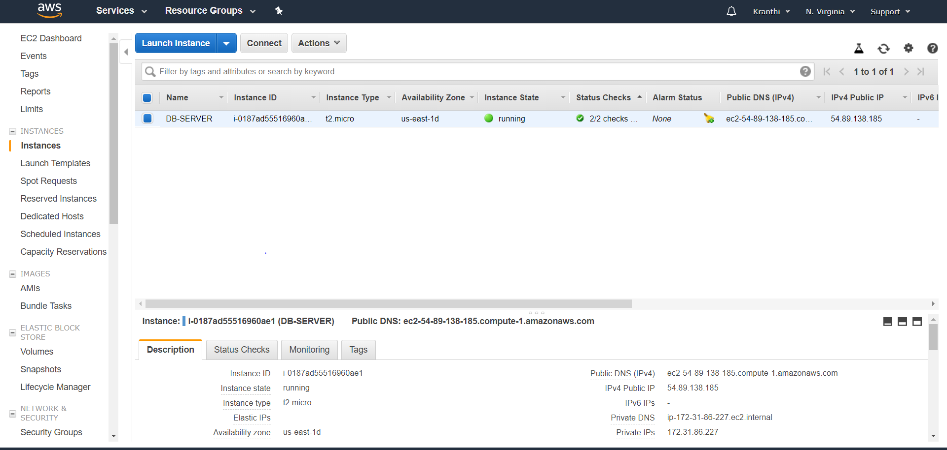

EC2 OUTPUT

**IoT Web Page**

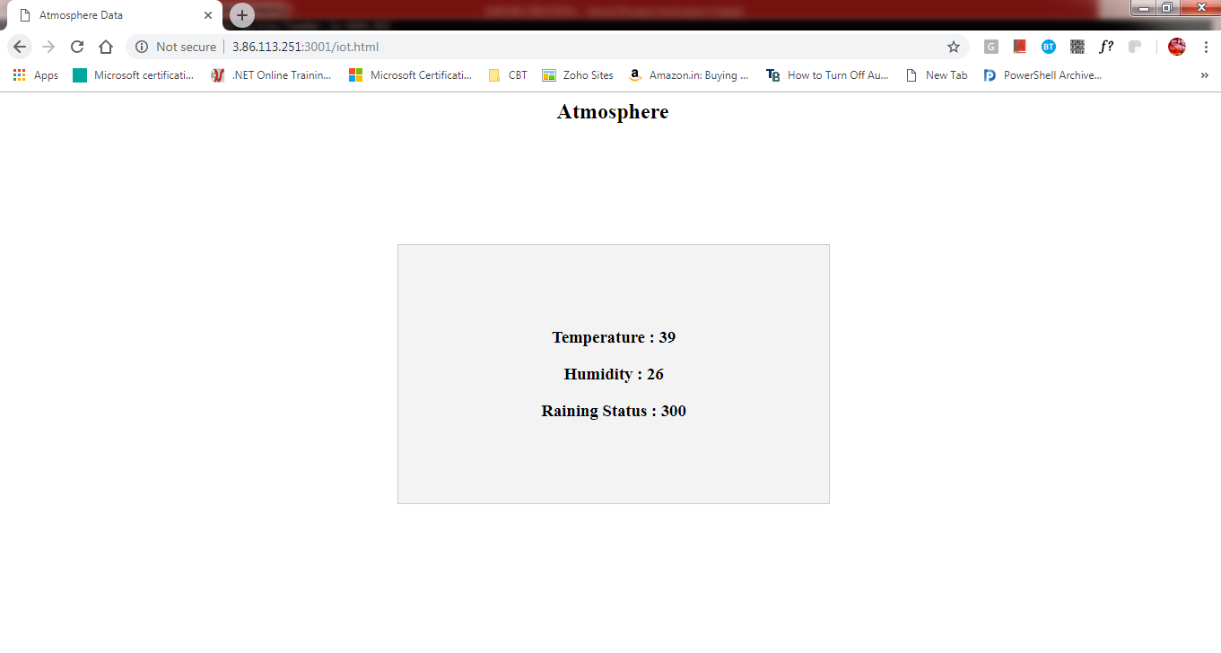

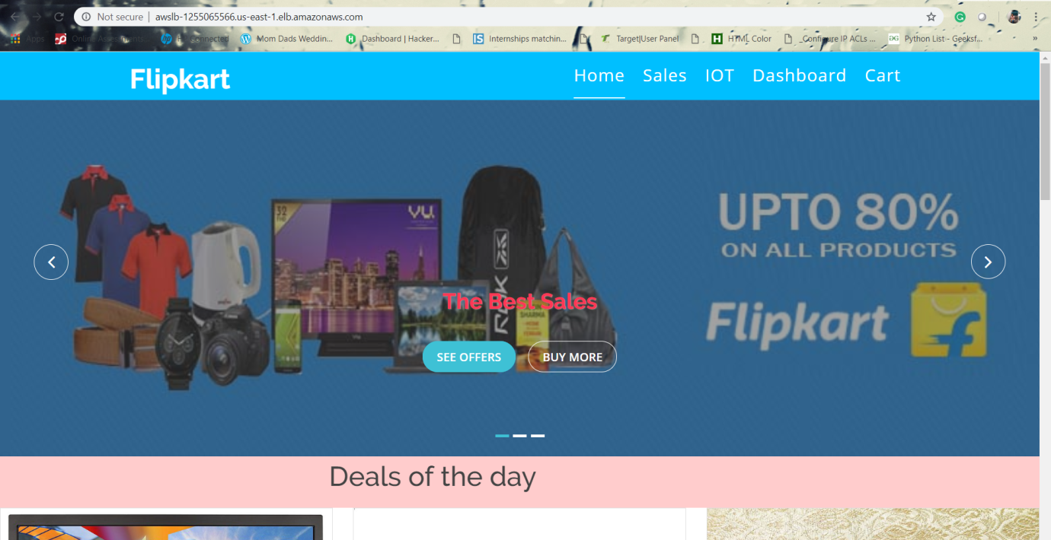

**Fig 8.2: Load Balancer URL of website**

We can notice the automatic addition of new instances, when c.p.u percentage goes high.

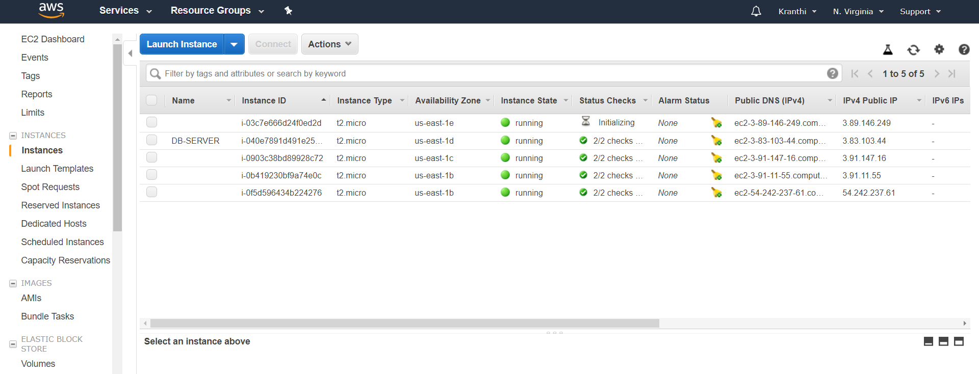

**Fig 9.1: Auto Scale in Output**

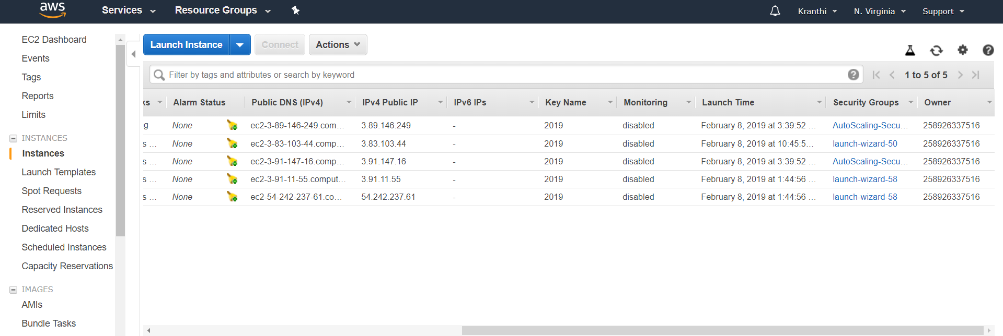

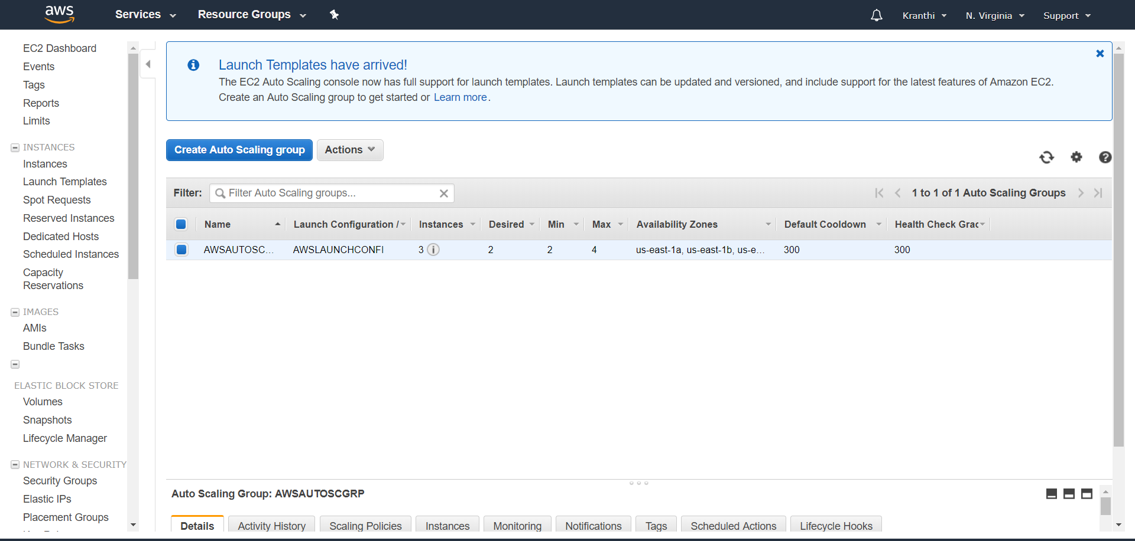

Termination of instances when the C.P.U percentage goes down.

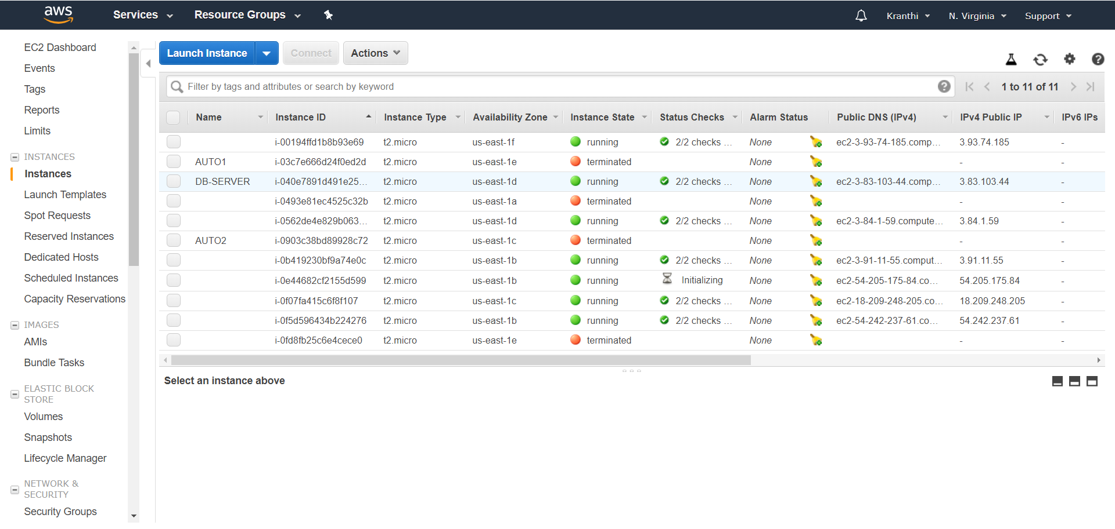**Fig 9.2: Auto Scale Out**

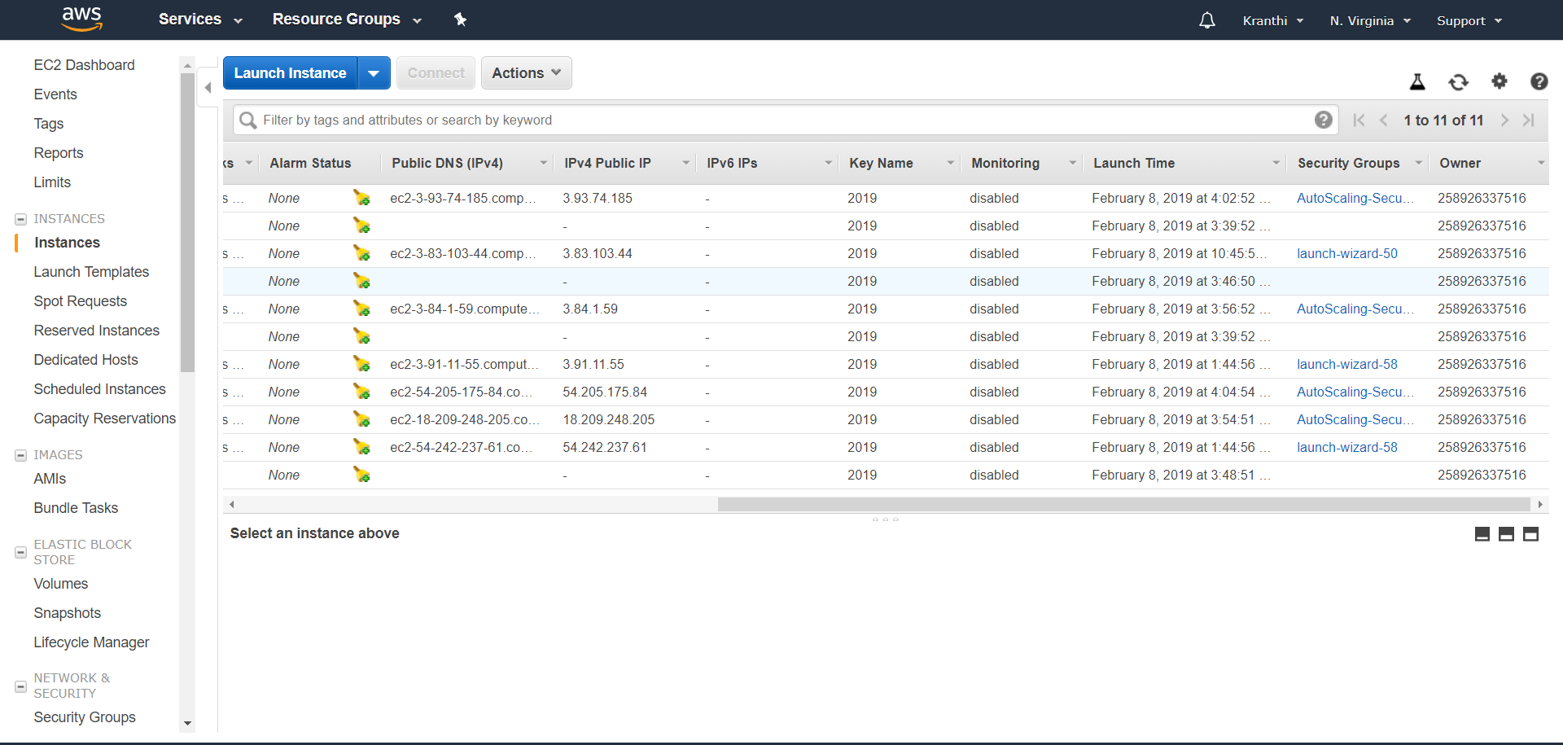

**Fig .9.3: Auto Scale Final Output**

**Output:**

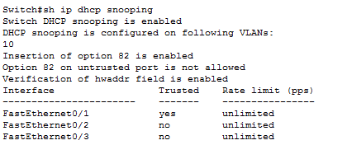

**Fig 10.2: DHCP Snooping Output**

Switch#

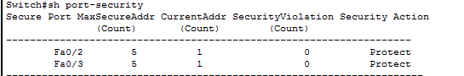

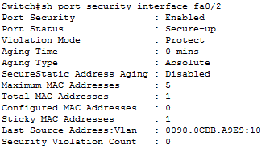

**Fig 10.3: Port Security Output**

**Output:**

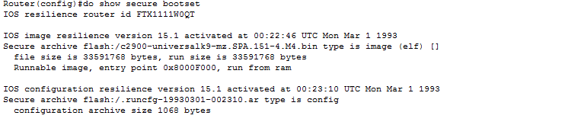

**Fig 10.5: Secured IOS Output**

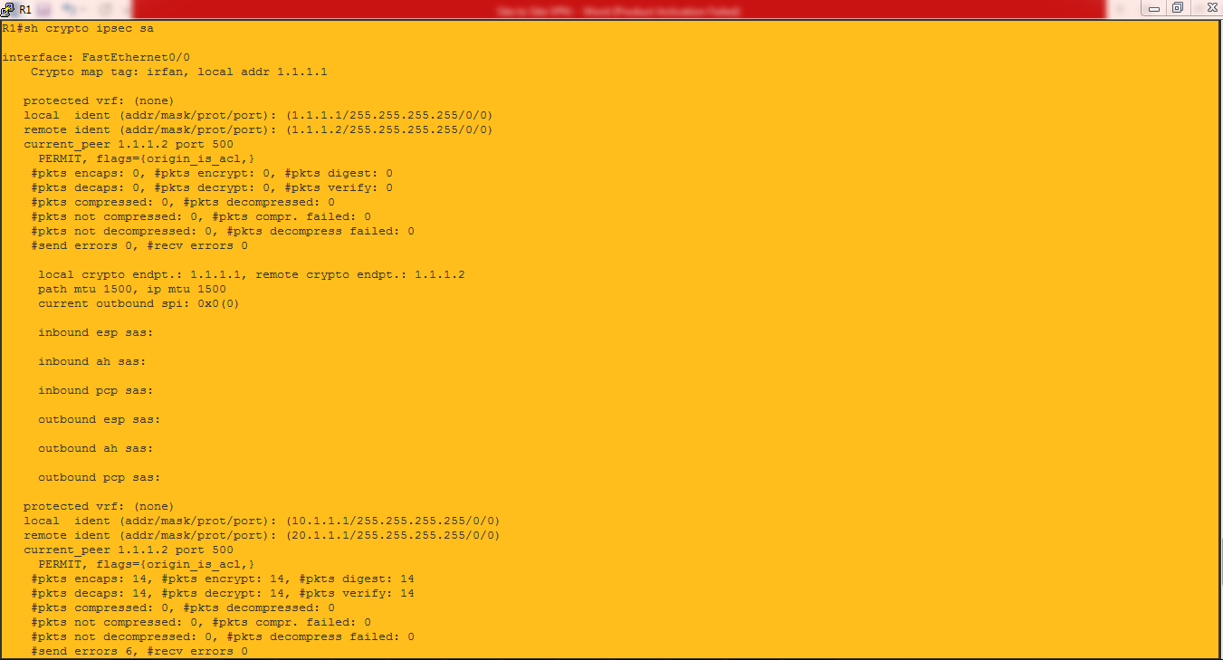

**Fig 10.6.1: VPN Output**